Here is my selected 2D image to make in 3D:

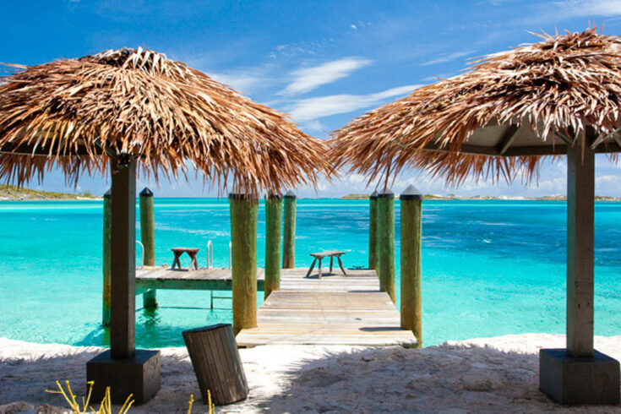

There are a lot of cool objects in this scene to replicate in 3D. I will replicate the two tiki umbrellas, dock, dock posts, and a ladder. These items will be great to replicate in a 3D scene, because they can all be broken down into simple 3D shapes. The two tiki umbrellas consist of a two boxes and a cone. The dock consists of basic boxes. The dock posts are a cylinder with a cone on top. Finally, the ladder is the most difficult but I think I can make one using a combination of cylinders and a torus.